Name: ______________________
Applying Accuracy and Precision to Data Sets
Describe each picture as having high or low accuracy and precision, and classify error.

___________________ ______________________ ___________________ ________________

___________________ ______________________ ___________________ ________________

Comment on the precision and accuracy, and identify what type of error (if any) may have occurred for the following sets of measurements. You will need to calculate the average, range, % error and % difference for each set of data given.

a. A group of students was determining the density of an unknown liquid. They obtained
Avg: _____
Range: _______
% error: _______
% diff: _______
the following values: 1.34 g/cm3, 1.32 g/cm3, 1.36 g/cm3. The actual value is 1.34 g/cm3.
_____This precision of this data set is ___________________________________________
________________________________________________________________________
_____The accuracy of this data set is_____________________________________________
__________________

b. Another group obtained the same results, but the actual value is 1.40 g/cm3.
Avg: _____
Range: _______
% error: _______
% diff: _______
________________________________________________________________________
________________________________________________________________________
________________________________________________________________________
__________________

c. A third group obtained the following values: 1.66 g/cm3, 1.28 g/cm3, and 1.18 g/cm3.
Avg: _____
Range: _______
% error: _______
% diff: _______
The actual value is 1.34 g/cm3.
________________________________________________________________________
________________________________________________________________________
________________________________________________________________________
__________________

d. A fourth group obtained the following values: 1.60 g/cm3, 1.70 g/cm3, and 1.40 g/cm3.
Avg: _____
Range: _______
% error: _______
% diff: _______
The actual value is 1.40 g/cm3.
________________________________________________________________________
________________________________________________________________________
________________________________________________________________________
____________________
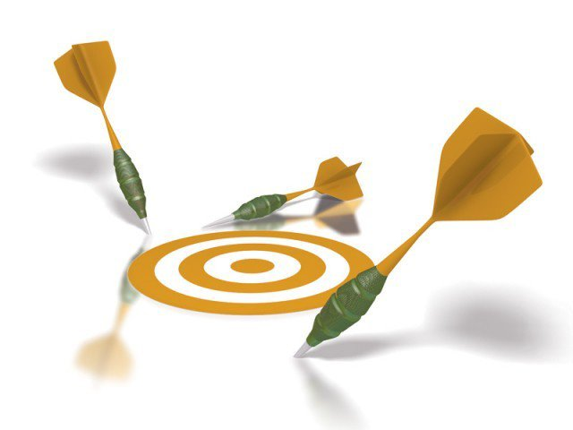
Now we will extend this activity to another unit of measure, specifically centimeters. Take a look at a ruler to visualize 1 cm.

Would you agree that one centimeter is not a very big length? ________

Can you think of an example of when being off by 1 cm is no big deal? Share your example with me.

Can you think of an instance or event when being 1 cm off with the measurement does matter? Share.

Now, think about one tenth of a centimeter, a millimeter.
Explain a time in which being off 0.1 cm may be acceptable.

Explain another time in which being off 0.1 cm may not be acceptable.

